ATOMBERG Case Study Final Report
- Ashutosh Singh

- Tools Used: -

Component | Tool Used | Purpose
Language | Python 3.13 | Coding and Analysis
Web Scraping | requests, BeautifulSoup4 | Scraping Data from Google and YouTube
Data Analysis | pandas, Numpy | Cleaning and transforming scraped data
Visualization | matplotlib | Plotting SOV & Sentiment Analysis bar charts
Text Embeddings | KeyBERT, transformers | Keyword extraction from Sentiment categories
Sentiment Analysis | transformers (DistilBERT) | Classify text into Positive, Negative, Neutral
LLM | Ollama (Locally running) | For summarizing or chat with insights

- Git HUB Link: -

- Additional: -
- Vector Database has also been created based on fetched data for any further Semantic searching using RAG pipeline for better fetching of data.
-

- N = 30 taken for scraping data from both Google and YouTube, this specific number has been taken for below reasons: -
- Relevance decreases with rank
- To avoid redundancy (Even in the 30 cases redundancy was found which was then removed)
- I got reasonable variety of data along with other brands data as well for doing my analysis
- For decreasing processing time and increase the speed of process.

- Outcomes Found: -
  - This could be seen that SOV performance for Atomberg is quite very nice compared to other brands in the data fetched

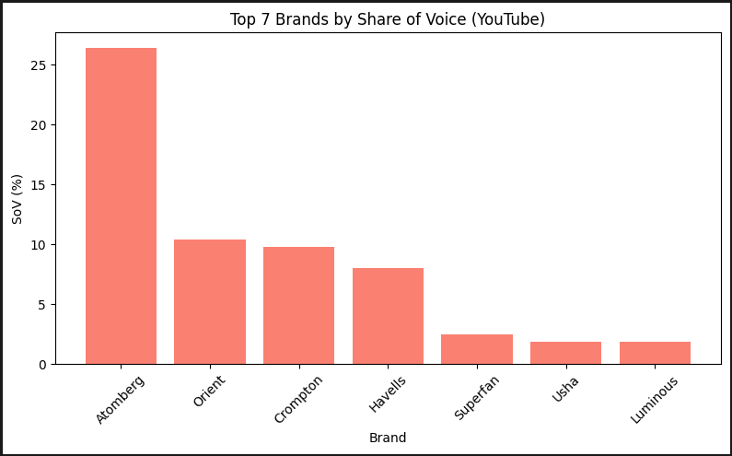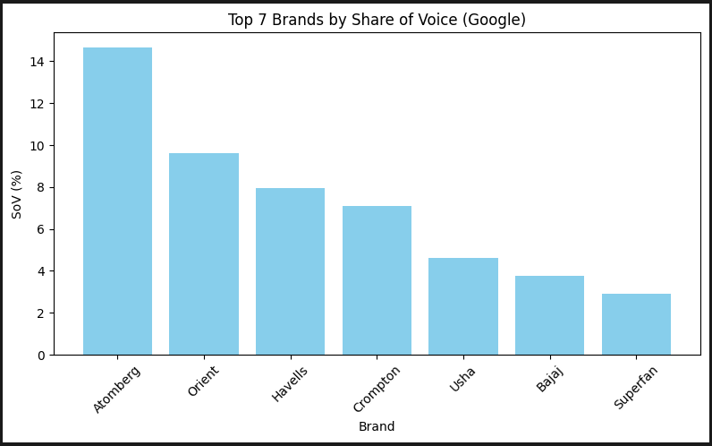

  - Sentiment Analysis shows varying results for Google and YouTube, there is no as such issue in customer sentiment analysis for Google scrapped data, but for YouTube data it could be seen that negative sentiments are there in case of Atomberg (2.33%) and is basically due to customer dissatisfaction from product and service.

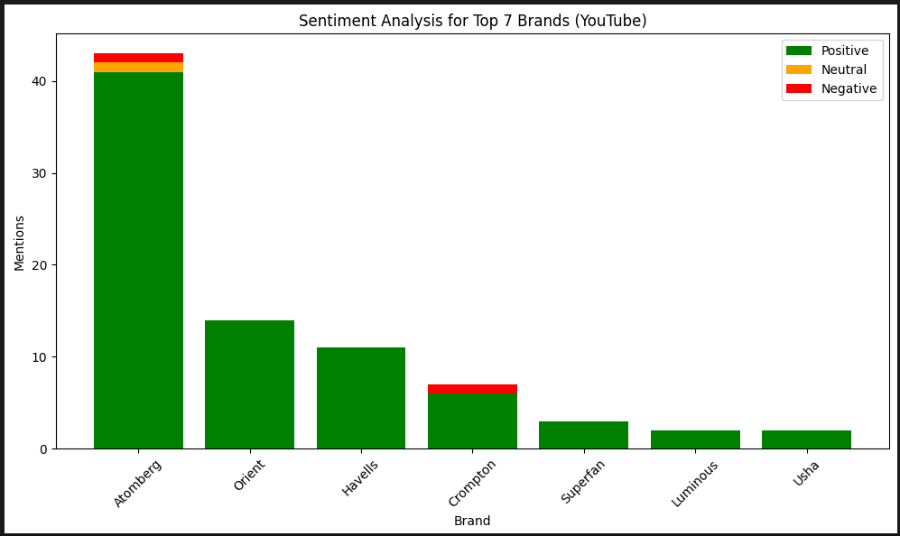

- Recommendation: -

  - Steps can be taken for the cases where Customer was not satisfied with product or service, handling of those customers and providing some kind of offer can change the negative reviews.

  - Otherwise compared to overall brands the SOPV performance is very high that needs to be maintained.

